Ring Weight Mounting Instructions
A Presto 4-quart stainless steel #01341  is the only cooker that the special machined ring weight is designed to fit. | 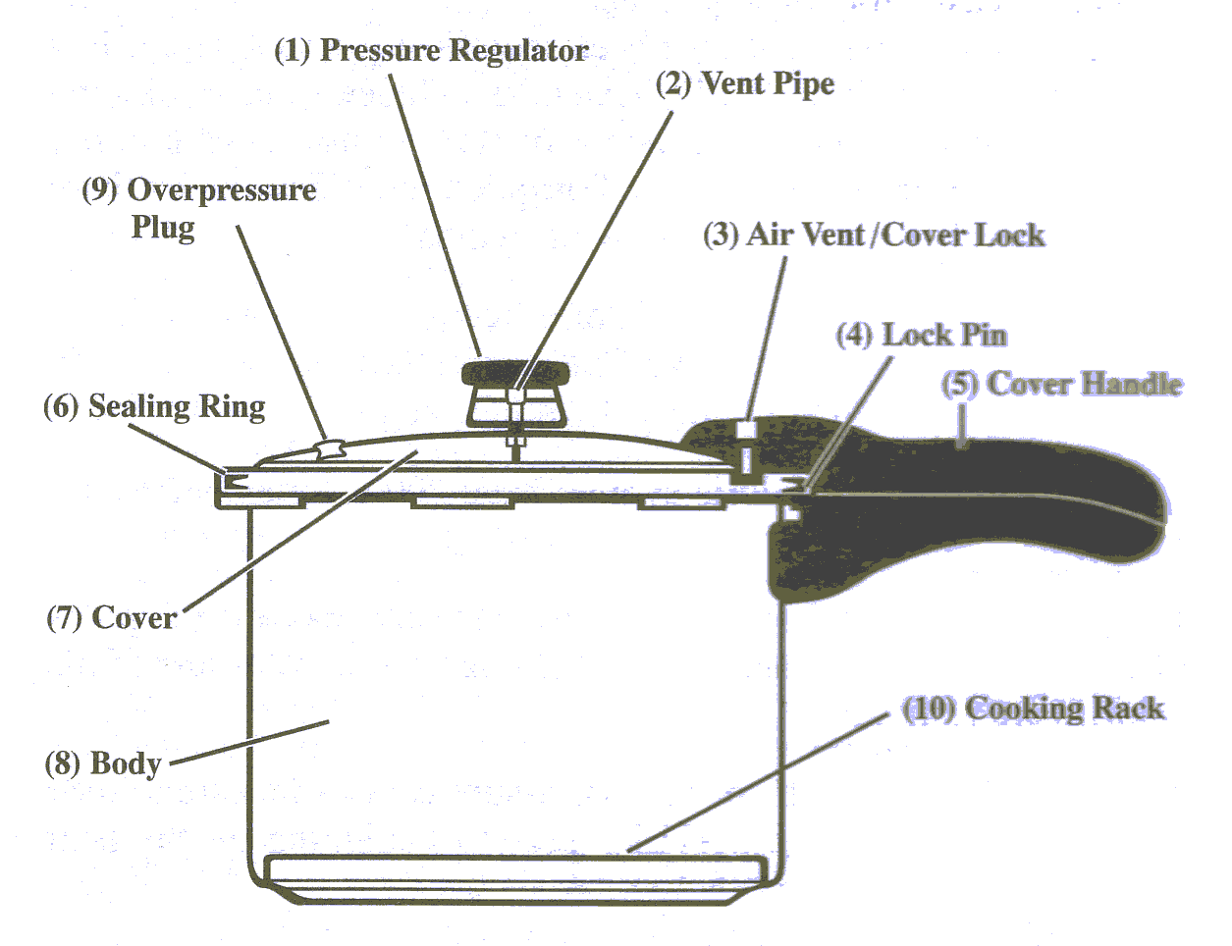
The ring weight increases the standard 16 pounds of cooking pressure to 24 pounds of pressure in the pot for absolute sterilization of your unbagged, unwrapped instruments.

Instructions for Sterilizing with Pressure Cooker
These instructions are for unbagged, unwrapped instruments.

You will need a heat source, such as an electric hot plate. Other items you will need are hot pads, oven mittens, clean towels, instrument tongs and a timer.

- Remove all blood and debris from your instruments before autoclaving.

- Place 1 1/4 to 1 1/2 cups of water in the bottom of the pressure pot. Always be sure that there is an adequate amount of water in the pressure pot to obtain the necessary pressure for sterilization. The cooker rack is your guide for the water level.

- Place the cooker rack on the bottom of the pot and load your instruments.

- Secure the lid onto the pot. Make sure that you hear the handles click to seal. Then place the pressure cooker on your heat source to begin the autoclave process.

- Once steam starts venting around the pressure regulator, start your timer. It takes 10 minutes to autoclave your instruments at 24 pounds of pressure with the ring weight. Maintain heat so the pressure regulator gently rocks back and forth during the cycle.

- After the 10-minute cycle with the ring weight, remove the pressure pot from the heat source and vent the steam by removing the pressure regulator/weight.

- Carefully remove the lid. Use tongs to remove the hot instruments and put them on a clean towel to bench cool.

- Caution: Do NOT overheat the pressure pot. The black safety plug pops out at 30 psi.

** The Ring Weight is made to fit the Presto 4-quart stainless steel cooker Model #01341

We purchase our pressure cookers online from
Red Hill General Store – Item #A41081
www.redhillgeneralstore.com or phone 800-251-8824

